HOW TO GET THERE
Porepunkah will be the base for the weekend’s event and is located 6 kilometres from Bright. The easiest way to get there for people travelling from the Melbourne direction is to take the B500 exit (Great Alpine Road) off the Hume Freeway approximately 15 kilometres from McDonalds at Glenrowan. For those coming from the Sydney direction take the same exit approximately 65 kilometres after you pass through Albury Wodonga. Once on the Great Alpine Road continue on following the directions to Myrtleford and Bright.
REGISTRATION

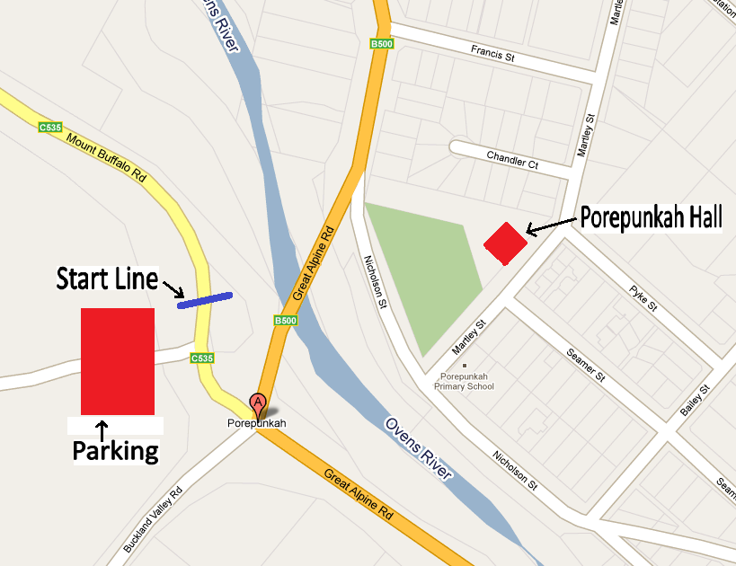

Registrations will take place at the Porepunkah Hall located on Martley Street between 6pm and 8pm on the Friday night. For those unable to register on the Friday registrations will also be available on the Saturday morning at the start area located on Mount Buffalo Road from 11am.

SCHEDULE OF EVENTS
Time Trial – Saturday - Start 12 noon (Start with W15 followed by M15, W17, W19, M17 & M19)

Road Race – Sunday - Start 8:15 am (M15 & M19)
Start 8:20 am (W15, W17 & M17)
Start 8:25 am (W19)

OPEN ROADS
Competitors should note that there will be NO road closure during the event. Normal road rules will apply at all times and riders must ensure they keep as far left of the road as possible at all times. Riders must NOT ride more than 2 abreast and must NOT cross the centreline of the road. All instructions from event Officials and Marshals must also be adhered to.

TIME TRIAL
All competitors will start on the Mount Buffalo Road north of the Porepunkah Roundabout and race against the clock to a finish point applicable to their particular age category. There will be no turnaround by competitors during the event. Competitors are reminded that it is not a race back to the start area and on their return to Porepunkah all riders must take particular care and travel at a sensible speed for a safe descent. The shortest distance will be 6 kilometres for the W15 while the longest will be 15 kilometres for the M19. No follow vehicles allowed

ROAD RACES
All races will finish at Dingo Dell on the summit of Mount Buffalo. Depending on the age category races will commence at either Rollasons Falls Car Park (W15), the entrance of Mount Buffalo National Park (M15 & W17) or in Porepunkah (M17, W19 & M19). The shortest distance will be 15 kilometres for the W15 category while the longest will be 66 kilometres for the M19. No follow vehicles allowed
SPARES
NO spares will be provided during either the Time Trial or the Road Race. This decision has been made in the interest of rider safety.

NEUTRALISATION
If for any reason conditions warrant the race will be neutralised. In such circumstances a red flag will be displayed from the leading vehicle.

PARK ENTRANCE
Mount Buffalo National Park has standard park entry fees which are charged during normal ticket office operating hours. The ticket office located at the park entrance is open between the hours of 8:30 am and 4:30 pm seven days a week. All vehicles entering the park during these hours are required to pay the appropriate entry fee.

SUPPORT VEHICLES
In order to help reduce the volume of traffic on the course during the Road Races all SUPPORT VEHICLES (parents & handlers) are required to pass through the park entrance before 8 am. Riders will need to be dropped off at their respective start points with sufficient time for their support vehicles to pass through the park entrance before this time. A condition of the permits issued for the event from Parks Victoria, Victoria Police and Vicroads is that NO vehicles other than OFFICAL vehicles will be allowed to follow the race. This will significantly reduce the volume of vehicles on the road during the event and will help in providing a much safer environment for the competitors. Once the last of the SUPPORT VEHICLES has passed the starting point for the Under 15 Women (Rollasons Falls Car Park) the under 15 Women will then commence their race. Their planned start time is 8.20am. Allow 20-25 minutes from Porepunkah to Rollasons Falls Car Park.
Only the OFFICIAL race photographers, motorcycle scouts and race officials will be allowed to travel up the mountain at the same time as the competitors.

NATIONAL PARK
As the event is being conducted in a National Park there are a number of additional rules that must be adhered to.
    - All competitors and officials must comply with all park regulations

    - Competitors and officials of the event do not have exclusive rights to any of the visitor facilities in the Park, including car parks and picnic areas. Other visitors must not be excluded from these areas.

    - All vehicles involved in the event must stop at the Park Entrance Station if entering the park from the Mt Buffalo Tourist Road during operating hours.

    - Competitors and officials must keep to existing trails and roads; this must be strictly adhered to given the fragile nature of a sub-alpine environment.

    - All rubbish must be placed in the bins provided or taken by the individual when they leave the park.

    - No marking or writing is permitted on any of the roads.

    - Native plants are not to be damaged or removed.

TIME TRIAL

Under 15 Women Start 12:00 pm
Start near Roundabout on Mount Buffalo Road and race for 6 kms to finish line near Park Entrance.
Under 15 Men
Start near Roundabout on Mount Buffalo Road and race for 8 kms to finish line near Eurobin Falls Picnic Area.
Under 17 Women
Start near Roundabout on Mount Buffalo Road and race for 8 kms to finish line near Eurobin Falls Picnic Area.
Under 19 Women
Start near Roundabout on Mount Buffalo Road and race for 10.4 kms to finish line.
Under 17 Men
Start near Roundabout on Mount Buffalo Road and race for 10.4 kms to finish line.
Under 19 Men
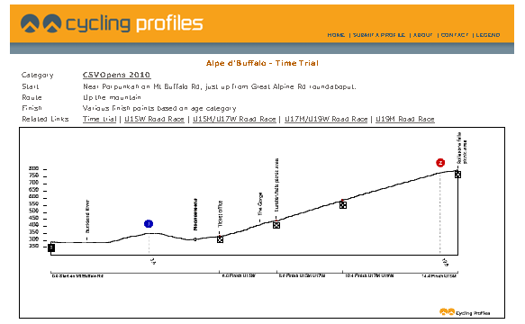
Start near Roundabout on Mount Buffalo Road and race for 14.4 kms to finish at Rollasons Falls Car Park.

ROAD RACE

Under 15 Women Start 8:20 am
Assemble at Rollasons Falls Car Park on Mt Buffalo Road approximately 15 kilometres from Porepunkah. Race straight to finish at Dingo Dell Car Park.
Riders will be under control for the initial 1 kilometre.
The under 15 Women will have the opportunity to do a stationary warm-up (Wind Trainer/Rollers); there will be no opportunity for a warm-up on the Mount Buffalo Road.
Under 15 Men Start 8:15 am / Under 17 Women Start 8:20 am
Assemble at Noonameena turnoff on Mt Buffalo Road approximately 6 kilometres from Porepunkah. Race straight to finish at Dingo Dell Car Park.
Riders will be under control initially until after the Ticket Office.
The under 15Men & Under 17 Women can warm up on the Mount Buffalo Road between the assembly area and the ticket Office when advised.
Under 17 Men Start 8:20 am
Assemble at Porepunkah Hall.
Ride under control up Martley Street, turning left into Francis Street before turning left onto the Great Alpine Road. Move on to Roundabout and turn right onto the Mount Buffalo Road. Race gets under way after the Buckland River and proceeds to the Ticket Box. Turn around at rear of Ticket Box and return to Roundabout at Porepunkah. U-turn at Roundabout and return to park entrance. Continue on to finish at Dingo Dell Car Park.
The under 17 Men, will warm-up on Seamers Street opposite the registration hall.
Under 19 Women Start 8:25 am
Assemble at Porepunkah Hall.
Ride under control up Martley Street, turning left into Francis Street before turning left onto the Great Alpine Road. Move on to Roundabout and turn right onto the Mount Buffalo Road. Race gets under way after the Buckland River and proceeds straight to finish at Dingo Dell Car Park.
The under 19 Women will warm-up on Seamers Street opposite the registration hall.
Under 19 Men Start 8:15 am
Assemble at Porepunkah Hall.
Ride under control up Martley Street, turning left into Francis Street before turning left onto the Great Alpine Road. Move on to Roundabout and turn right onto the Mount Buffalo Road. Race gets under way after the Buckland River and proceeds to Ticket Box. Turn around at rear of Ticket Box and return to Roundabout at Porepunkah. U-turn at Roundabout and return to park entrance. Complete two more laps of Roundabout – Ticket Box Loop before continuing on to finish at Dingo Dell Car Park.
The under 19 Men will warm-up on Seamers Street opposite the registration hall.

